**Android App Testing Screenshots**

Receptionist Signup

Row No.: 6

|  |  |  |  |  |
| --- | --- | --- | --- | --- |
| **Description** | **Test Steps** | **Expected Output** | **Status** | **Comments** |
| Verify welcome message or username display | 1. Login with a receptionist account 2. Observe the welcome screen | 1. A welcome message or the username should be displayed 2. The message should be personalized with the user's name | **Fail** | When logged in with a receptionist account, the welcome screen is displayed, but does not show a personalized message with the user's name. |

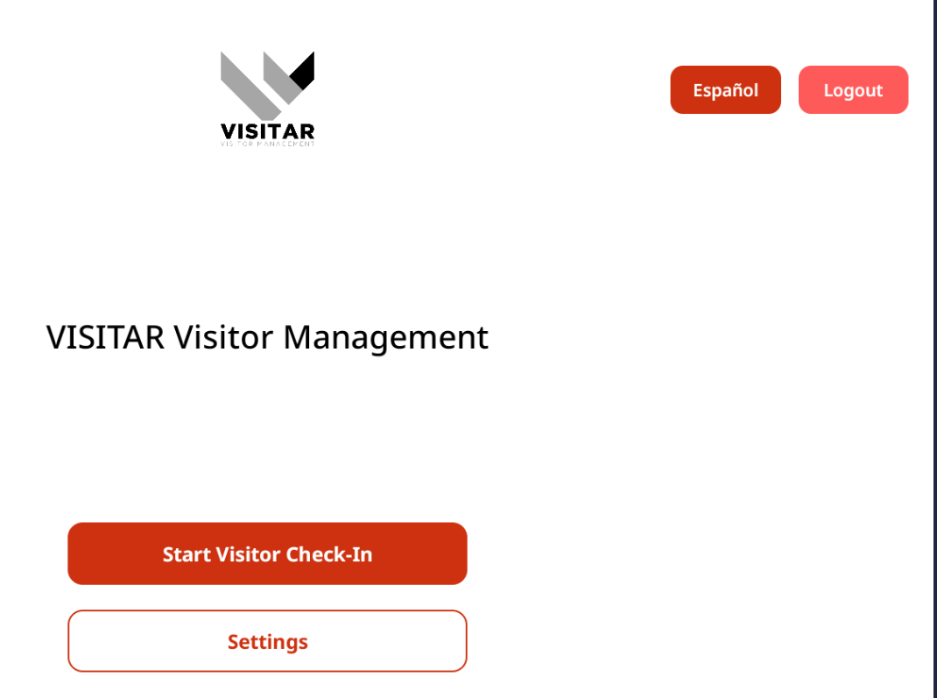

Row No.: 8

|  |  |  |  |  |
| --- | --- | --- | --- | --- |
| **Description** | **Test Steps** | **Expected Output** | **Status** | **Comments** |
| Verify visitor management page access from check-in option | 1. Click on the check-in option from the welcome screen 2. Observe the visitor management page | 1. User should be navigated to the visitor management page 2. Visitor management page should load completely 3. All visitor management functions should be accessible | **Fail** | When the check-in option from the welcome screen is clicked, user is navigated to the Visitor Information page.  Visitor management functions are not displayed |

